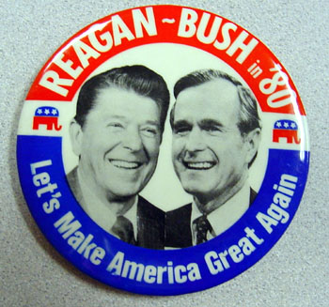
THE CONSERVATIVE TIDE OF REAGAN AND BUSH

- Why did many Americans embrace the conservative movement?
- How did this “New Right” differ from the “New Left” of the 60’s and 70’s?
- Which groups formed the conservative coalition and how did they gain support?
- What was the moral majority and what beliefs set them apart?
- List the goals of the Conservative Movement
- Summarize Reagan’s early political career
- Describe the qualities that Reagan possessed that helped him win support over Carter in the election of 1980. What was his appeal to voters?
- What issues were important?
- Looking at the map of the 1980 election results, does it surprise you that Reagan won by such a HUGE lead? Why do you think this happened?
- President Reagan announced his new economic program REAGANOMICs which called for a reduction in income tax for individuals and a big reduction in government spending. What were the three parts of Reaganomics?
- Summarize how REAGANOMICS impacted the following:
Budget Cuts:

Tax Cuts:

Defense Spending:
Recession and Recovery:

The National Debt:

- How did the Supreme Court influence and impact the conservative movement? How was this different than from the past?
- Define deregulation
- How did Reagan accomplish deregulating the economy? Explain
- Do you agree with Reagan’s action regarding the EPA? Defend your opinion
- How did Reagan’s response to his assassination attempt reflect his personality?
- On page 1043 it lists the four major voter coalitions of the new conservative movement. In your own words explain why each group would support Reagan. What did they have to gain?
- Reagan ran for reelection in 1984 and won by a landslide. V.P. George Bush ran in the election of 1988. What were the strong and weak aspects of his campaign?
FURTHER RESEARCH: pg. 1045-1047
- List the five areas of public life that were affected by the conservative movement. Elaborate Reagan’s feelings, actions and how federal policy changed in that area during Reagan’s presidency.
- Identify and record three groups in American history who welcomed Reagan’s presidency and three groups who did not. What did each group feel that they lost or gained under the Reagan administration?
- Summarize the qualities that made Reagan an effective president and qualities that he may have lacked as a national leader.
**You will have a short quiz Friday after the final lecture on Reagan’s policies. The more research you complete the better prepared you will be

