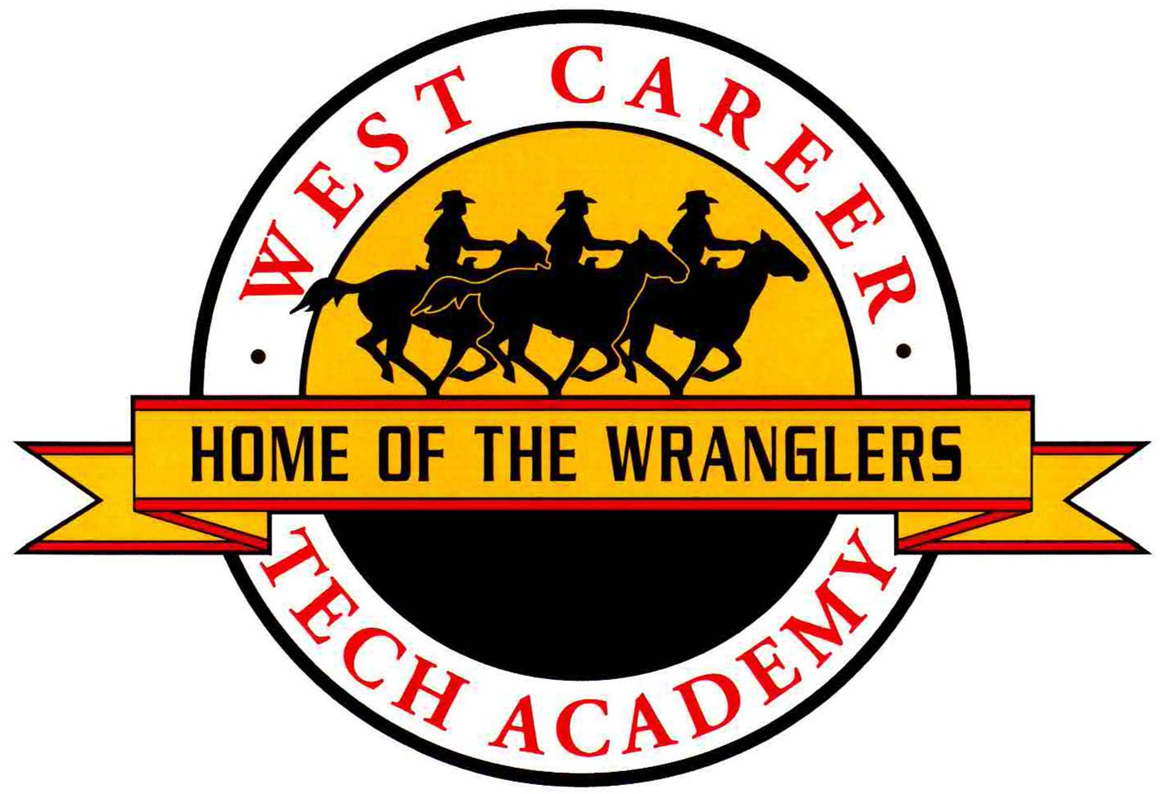
Course: United States History AP

Instructor: Adriane Casolari

Contact information:
Telephone Number: 799-4340
Instructor Email: aanderson@interact.ccsd.net
Or adrianea@gmail.com (I will check this email up to 7:00 pm)
School website: acasolarisclass.weebly.com

ADVANCED PLACEMENT COURSES AT WEST CAREER & TECHNICAL ACADEMY

West CTA believes that all students should have the opportunity to enroll in Advanced Placement courses. Students will be encouraged to work to the highest level of their potential in an encouraging and supportive environment. Advanced learning is the ultimate result.

An AP course is considered a college-level class that may result in a student earning college credit; students must be certain they are ready to meet the challenges of a college curriculum. They must be organized and self-disciplined, with above average reading and writing skills. Learning is only successful when students are actively engaged in the process; therefore, what they achieve will depend on their personal commitment and involvement. Parents/guardians should be aware that the rigor of an AP course(s) may impact the time and preparation a student must undertake at home. Some courses also require summer reading and/or writing assignments.

Instructors will need to move very intensively through a tremendous amount of material to prepare students appropriately. Therefore, it is imperative that students attend class every day. If a student must be absent, it is the responsibility of the student to find out what work was missed and to complete the assignments in the designated time frame.

After completing the AP course students should be well prepared for the exam that culminates each course. The culminating assessment for an AP course is the AP Examination; at WCTA, all students enrolled in an AP course are required to take the examination in May. The cost of the exam is $93.00. Financial assistance is available. You may contact our AP Coordinator for more information. WCTA requires a $15 deposit for all AP Tests. This deposit is not refundable and is due by Wednesday, September 14, 2016. You may pay your AP Test fees by cash or credit card. WCTA does not take checks.

Reminder:
$15 per test deposit due Wednesday, September 16, 2015 (before Open House)

for more information on testing policies and procedures
contact Mrs. Klemp, our AP Coordinator
dklemp@interact.ccsd.net

2017 West CTA AP Exam Schedule
Week 1 | Morning 8am | Afternoon 12pm
Monday, May 1 | Chemistry  Environmental Science | Psychology
Tuesday, May 2 | Spanish Language & Culture | Physics I: Algebra Based
Wednesday, May 3 | English Literature & Composition | Physics II: Algebra Based
Thursday, May 4 | US Government and Politics
Friday, May 5 | US History  Studio Art Portfolio Submission
Week 2 | Morning 8am | Afternoon 12pm
Monday, May 8 | Biology
Tuesday, May 9 | Calculus AB  Calculus BC | Spanish Literature & Culture
Wednesday, May 10 | English Language & Composition
Thursday, May 11 | World History | Statistics

for more information on testing policies and procedures
contact Mrs. Klemp, our AP Coordinator
dklemp@interact.ccsd.net

Course Scope:
This one-year course surveys the exploration period to the present. Emphasis will be put on the major themes of America’s development and its relations with other nations. Students will study all major political, economical, and social institutions. This course will fulfill the one United States history credit required for graduation

Course Goals:
-To acquire an appreciation of our American heritage
-To apply the knowledge of our past as means of exploring the present
-To understand how geography shaped the way the U.S. developed
-To understand the impact of social, economic, and political institutions on United States history
-To evaluate popular trends during the course of United States history
-To analyze the role of the United States involvement in armed conflicts
-To understand the historical development of the United States economic system

Textbook(S): Boyer, Paul S., The Enduring Vision. Seventh Edition

Pacing- (Approx. two/ three periods per quarter)
*This will be a rigorous course, but it will also be enjoyable. Hard work and dedication will be essential to success.
Quarter 1: Pre-Columbian Societies to Territorial Expansion and Manifest Destiny
Quarter 2: The Crisis of the Union to Populism and Progressivism
Quarter 3: Emergence of America as a World Power to The Home Front during the War
Quarter 4: Early Cold War to The United States in the Post–Cold War World

*Once all material is covered, approximately two weeks will be available before the AP exam on Friday May 5th. There will also be after school reviews that are optional for students to attend. During this time we will review material, take practice tests and look at examples of past tests. Whether you are taking the exam or not, you will be graded on this work because of your enrollment in an AP course.

** CCSD regulation has changed-- students who do not take the AP test will earn honors credit on their transcripts. Only students who take the AP test will earn the AP weighting

Course Materials: LARGE SPIRAL Notebook (handout explaining organization will be given in class), small spiral notebook for essay writing, bell-ringer questions, pencil, blue/black ball point pens, and highlighters.

**You need to bring these supplies to class EVERYDAY!

Grading Policy: The purpose of grades is to provide effective feedback to students, parents, and the school administration about a student’s progress towards mastery of the established standards for a particular course or subject. It is important to note that excessive absences (seven unexcused absences during a semester) may result in a loss of credit in accordance with CCSD Regulation 5113.

Extra credit will not be permitted unless the work is specifically designed to provide more evidence of a student’s progress towards mastery of the established standards.

Students will be graded on a 0-100 point scale, with the following grade equivalents:
90-100 | = | A
80-89 | = | B
70-79 | = | C
60-69 | = | D
0-59 | = | F

Semester grades will be calculated as follows:

First Quarter Grades | 42.5% of the semester grade
Second Quarter Grades | 42.5 % of the semester grade
Semester Exam | 15% of the semester grade  Note: Digital Portfolio is a component of the semester exam and is counted as 5% of the semester grade.
Semester Grade | 100%

Quarter Grade Assignment Categories will be weighted as follows:

Type of Assignment | Weighting for Quarter Grade
Content Mastery | 60%
Skill Development | 30%
Employability Skills | 10%

Citizenship Policy:
The following rubric will be used as a general guideline to determine student citizenship grade:

CATEGORY | Outstanding | Satisfactory | Needs Improvement | Unsatisfactory
Engagement | Consistently involved in class activities; contributes to overall learning process; collaborates with others and/or the teacher. | Engages in class activities, but may have to be encouraged; works with others or groups, but may not initiate collaboration. | Does not engage in class activities; rarely demonstrates initiative and may occasionally disengage from class. | Consistently uninvolved in class activities. Adamant refusal to work.
Preparation | Consistently prepared with materials; work is on time and may go beyond expectations. | Student has materials and submits work in a timely fashion and as expected. | Student may have had multiple instances of being unprepared, late work, or not completed as requested. | Consistently unprepared for class. Does not submit work on time or at all.
Behavior | Consistently respectful of both classmates and adults; takes responsibility for individual actions; consistently complies with school and classroom rules. | Respectful to both peers and adults. Occasionally accepts personal responsibility. Mostly complies with school and classroom rules. | Disruptive to others. Argumentative and defensive when disciplined. Disregard for school or class rules. | Consistent disrespect to classmates or adults. Regularly disruptive to learning process and violation of school or class rules.  Plagiarism / Academic Dishonesty

Student citizenship grades are reported as follows:
O = Outstanding
S = Satisfactory citizenship
N = Needs Improvement
U = Unsatisfactory citizenship

Behavior Expectations:
It is a goal of West Tech Academy to create a college-like atmosphere where students, staff, teachers, and administration interact in a collaborative, professional, and responsible manner. Basic behavioral guidelines include:
- Students will not interfere with teacher instruction.
- Students will not interfere with another student’s learning.
- Students will not engage in behaviors that are not in their best interest, the best interest of others, or in the best interest of West Tech Academy.
- The CCSD Honor Code will be strictly enforced.
- The Acceptable Use Policy (AUP) regarding the use of technology must be followed at all times.
Students and parents are responsible for reviewing the CCSD Student Behavior Guidelines/Honor Code/AUP, the WCTA Student Handbook, and the WCTA Tardy Policy.

Makeup Work / Late Work
All assignments are due at the beginning of the period on the established due date. You may NOT print your assignment in class. It is your responsibility to go to the library, or a classroom, before school in order to print and to come to class prepared.

After any absence, a secondary student is required to initiate contact with the teacher(s) to obtain appropriate makeup work within three school days immediately following the absence. Once contact has been made with the teacher(s), specific makeup work must be completed and returned to the teacher(s) within a reasonable length of time, to be determined by the teacher and communicated to the student/parent or legal guardian. The makeup work must be returned to the teacher(s) by the specified due date if it is to be acknowledged. Students shall be allowed a minimum of three (3) days to complete makeup work.

Any graded assignment that is submitted beyond the three days allocated for make-up work will be considered late work. Late work will be accepted up to the preparation of the unit test for reduced points. NO WORK will be accepted after it has been tested upon so please be aware of due dates.

The Class Calendar
In U.S. History AP it will be your responsibility to check the website calendar daily for assignments, tests, or announcements. There will be a calendar just for your class that will outline the class activities and homework. If you are absent please check this site and follow up with any questions you may have with your instructor. Mrs. Casolari follows the three-day rule outlined by CCSD.

If you are absent from class on the day of a project or quiz please email the instructor to make arrangements. If possible, prior notice is appreciated. When working on a group project, students must communicate with peers/teacher if they will miss presentation day. If no communication is given, presentation points will be lost.

Tardy Policy
A school-wide tardy policy will be enforced at WCTA. Important items to be aware of include:

- Students arriving to class after the tardy bell without a pass will be marked tardy.
- If the student is more than 30 minutes late to any class period, the student will be marked absent. If the student is late due to a medical appointment, the parent/guardian must provide documentation to the attendance clerk when the student arrives on campus.
- Students tardy to class will be subject to the discipline appropriate for the circumstance and the number of times tardy (as stipulated by the school’s tardy policy).

Computer Use
The WCTA has a powerful student WIFI system which extends throughout the school campus. Students will be able to use their own laptops and tablets during class (at appropriate and/or directed times), at lunch, as well as before and after school. They will learn how to use Google Apps and other internet based resources to store files, manage their digital portfolio, and collaborate electronically. An emphasis will be placed on the appropriate use of technology.

Thank you for reading through these course expectations and following the guidelines created specially for this class. I am looking forward to making this school year amazing and with collaboration it will be!

United States History AP
Adriane Casolari
This page must be returned to the course instructor by: 9/9/2016

Print student name ______________________________ ID Number: ____________________

Having read the Course Expectations for the United States History AP my signature indicates that I understand the policies that are outlined and explained in the Course Expectations, especially the following policies:
- All students enrolled in an AP course are required to take the AP Examination.
- AP Exams are $93.00; a deposit of $15 per test is due by September 14, 2016.
- The full cost of the AP exam is due by, when Spring Break begins.
- CCSD regulation states that if a student does not complete the AP Exam, he or she will not receive the increased GPA weighting for AP Courses. Students who do not take the exam will receive honors credit.
- AP Exam fees can be paid at the school banker by cash or credit only. WCTA does not take checks.
- My signature on this course expectations document constitutes my official registration and agreement to pay for the AP Exam in the course listed above.
- Successful completion of the AP course requires intensive study and work outside of class.

The parent/guardian may contact the instructor or the AP Coordinator with questions before signing.
_______________________________________________ Date _________________________
Student Signature

_______________________________________________ Date _________________________
Parent Signature

